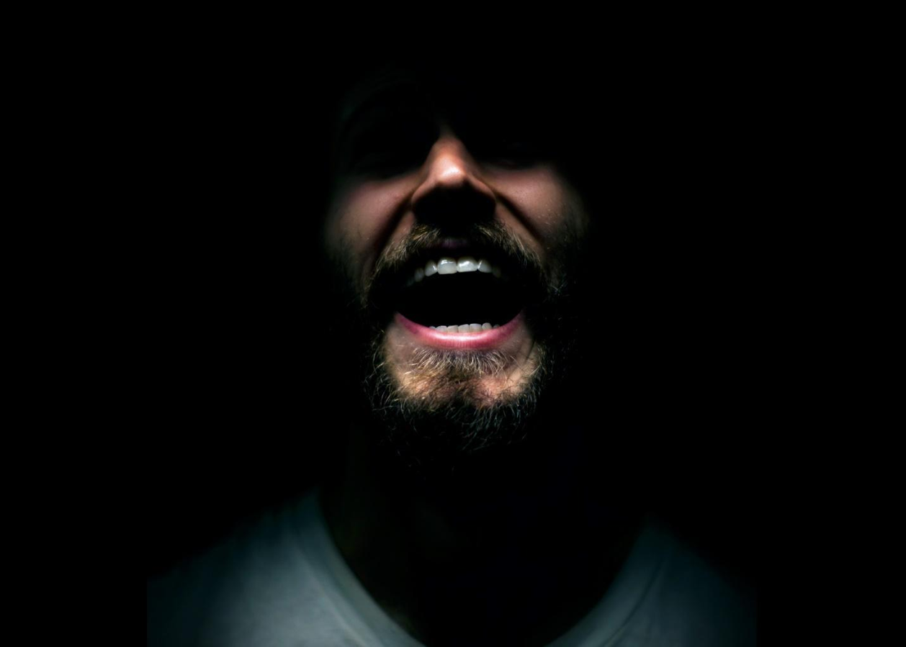

THEY LOOK LIKE PEOPLE
a film by Perry Blackshear

2015 / USA / English / Drama-Psychological-Mystery
80 min / HD / 16:9 / Dolby 5.1

theylooklikepeople@gmail.com
theylooklikepeople.com
MAJOR FESTIVALS AND AWARDS

Slamdance International WINNER **Special Jury Prize** World Premiere
IFF Boston WINNER **Grand Jury Award**
SF IndieFest WINNER **Grand Jury Award**
Nashville International WINNER **Grand Jury Award – Graveyard Shift**
WINNER **Audience Award – Graveyard Shift**
Fantasia WINNER **Most Innovative Film** International Premiere
Chicago International (upcoming)

REVIEWS

-Verite Film -Film School Rejects -Scream Magazine -The Hollywood News

-Screen Relish -Nerdly -Modern Horror -Libertas

- Almas Oscuras -The Movie Guru -Sean Kelly - Cut Print Film

- Cinemaiak -Efilm Critic -Salty Popcorn -SciFi Now

LOGLINE
Suspecting that those around him are actually malevolent shape-shifters, a troubled man questions whether to protect his only friend from an impending war, or from himself.

SHORT SYNOPSIS
Suspecting that people are transforming into malevolent shape-shifters, Wyatt flees to New York City to seek out his estranged childhood friend Christian. As the mysterious horrors close in on Wyatt, he questions whether to protect his only friend from an impending war, or from himself. A genre-bending story about love, loyalty and living nightmares.

MAIN CAST AND CREW

Wyatt MacLeod Andrews
Christian Evan Dumouchel
Mara Margaret Drake

Writer / Director / Editor / Director of Photography
Perry Blackshear
Producers Kimberly Parker, Perry Blackshear
Co-Producers Evan Dumouchel, MacLeod Andrews
*** PRESS NOTES ***

“This is a film that sneaks up on you and then hits you over the head.”
-Unseen Films

“Perry Blackshear’s minimalist, powerful psychological horror film expands that passing moment of alienation felt by most people into a nuanced, empathetic, and suspenseful portrayal of paranoia. “
-The Boston Globe

“Blackshear examines love – true, lifelong friendship – in a way that has maybe never been explored as authentically in a horror film before. It’s this genuineness, this abiding tenderness Christian and Wyatt have for each other, that makes the film so moving and, simultaneously, so deeply scary.”
-Screen Relish

“A tense psychological thriller with two of the most endearing best friends since Bill and Ted. They Look Like People is what would happen if Donnie Darko grew up.”
-The Hollywood News

“The chemistry between Andrews and Dumouchel is the glue, their performances rich and playful in nuance. Both are brimming with self-doubt, old wounds, new confidence. That masculine insecurity, that fear of being less than is a thing men often hide away for the very reasons it propels. They Look Like People explores such bruised and battered places deftly, tenderly, honoring the pain, never treating Wyatt as a crazy person, and accepting something greater in friendship. Which all comes to a head by the heart pounding finale.”

-Twitch

“I was leaning forward, waiting on every word, every action, unable to predict what was going to happen next. This film firmly marks the arrival of a new director, Perry Blackshear, to keep a close eye on, as if this is what he can create with his first film on a self-described micro-budget, I cannot wait to see what he will do with his second attempt. This is a film like no other.”

-Salty Popcorn

“They Look Like People offers up two fragile souls, both suffering and under attack in their own way, and suggests that the most powerful defense in their arsenal is the love, friendship and empathy they have for someone else. The film may look like a suspenseful thriller about a dangerously insane young man, but shimmering beneath the surface is a movie about the people we are, the people we want to be and the people who stay by our side along the way.”

-Film School Rejects

"Well done!"

-Perry's Mom

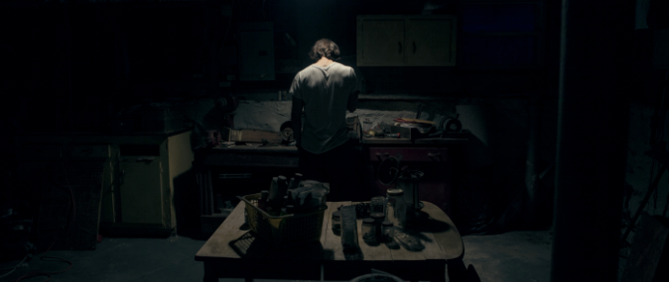

DIRECTOR'S STATEMENT
Years ago, my best friend was going through a bad time. In his dreams, people he loved died gruesome deaths. He began to believe normal people were becoming replaced with “fake” people. Evil people.
In our weakest moments, we have all felt this. Betrayals at work, within relationships, within family, between nations, transform those around us into monsters. My friend told me later that there was one week during that period in his life, where if he didn't have a few good friends holding onto him, he would be in jail or dead.
They Look Like People is about these characters, a troubled young man and his former best friend, and takes place during that one week. Even though the movie was originally intended as more of a genre piece, They Look Like People accidentally became the most personal film I have ever made. The movie has the backbone of a psychological thriller, but at its heart it is a love story.
The films asks the question, “Should I care about others, even if it means I might get torn to bloody shreds?”

WRITER & DIRECTOR BIOGRAPHY

PERRY BLACKSHEAR – Writer, Director, Producer, Cinematographer, Editor

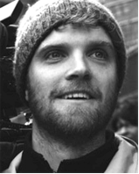 Perry Blackshear spent most of his childhood wishing he was a mountain lion. Perry is an alumnus of NYU’s Graduate Film Program, the IFP Emerging Narrative Lab, and the IFP Post-Production Lab. He currently works at a digital agency in Brooklyn while preparing his second feature film
MAIN CAST/CREW BIOGRAPHIES

MACLEOD ANDREWS – Wyatt, Co-Producer

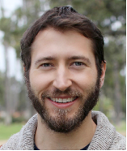 Macleod Andrews is a company member of Rising Phoenix Rep Theater Company in NYC and has performed in a number of shows Off-Broadway including Slipping with RPR & Rattlestick Playwrights Theater. March 2015 he will be performing in Thieves by Charlotte Miller commissioned by RPR and Rattlestick. He will be producing and starring in a new horror feature entering production in late 2015. He also leads a double life as an award winning audiobook narrator, with over 200 titles to his credit.

EVAN DUMOUCHEL – Christian, Co-Producer

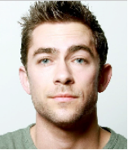 Evan Dumouchel is an actor and filmmaker living in Los Angeles. His recent credits include Movie 43 and 40 Days and Nights. He will be performing in Vivian Bang’s upcoming film Lift Others: LA Love Story. He too leads a double life, his having to do with computers. He is currently directing a project showcasing members of The Lab Creative in Los Angeles.

MARGARET DRAKE – Mara

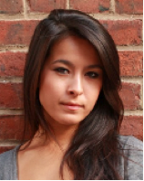 Margaret Ying Drake is an actress and native New Yorker who studied theatre at Skidmore College. She has worked in theatre, film, commercials, and voiceovers; cast in projects with Nickelodeon, Scholastic, the Food Network, PBS, and more. Margaret performs regularly with her dance company Dance Soul Co. in NYC.

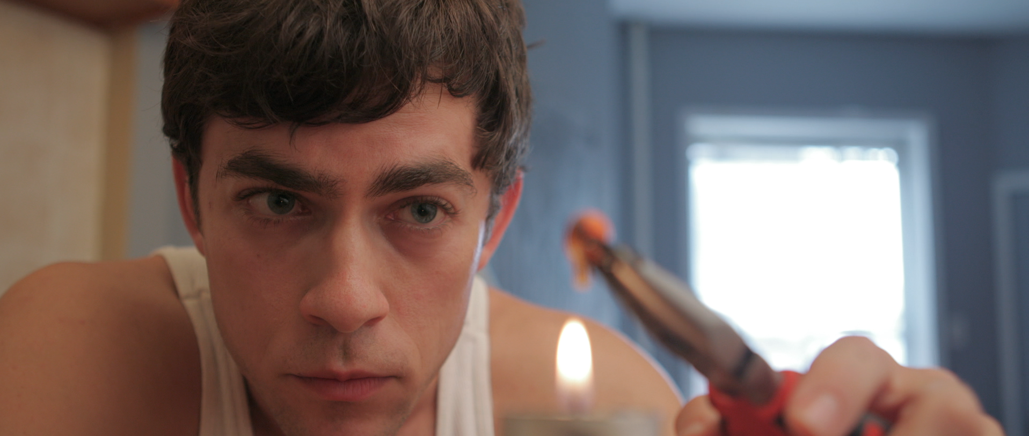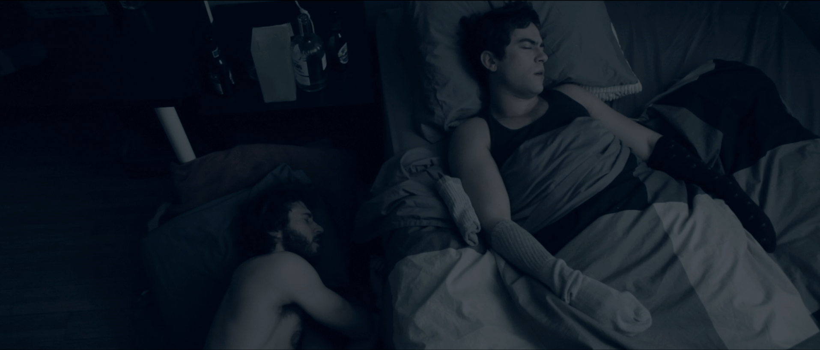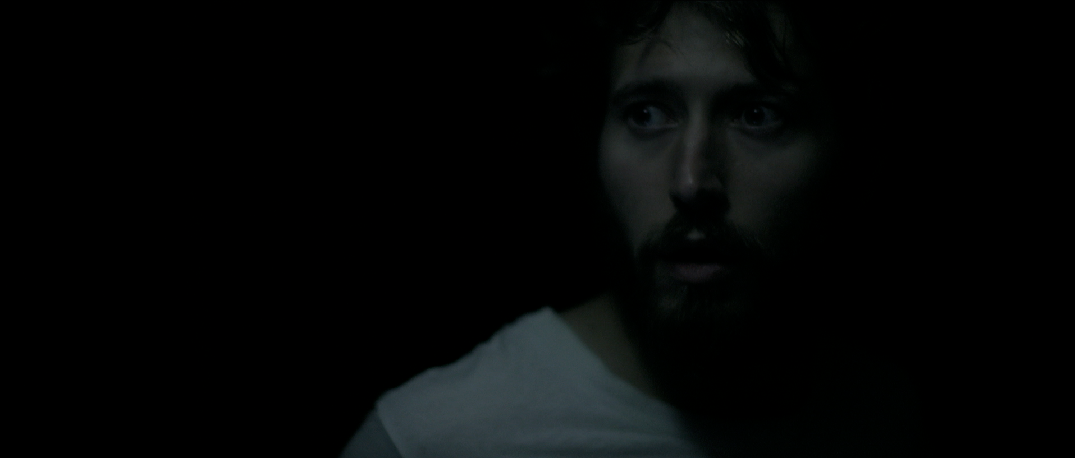

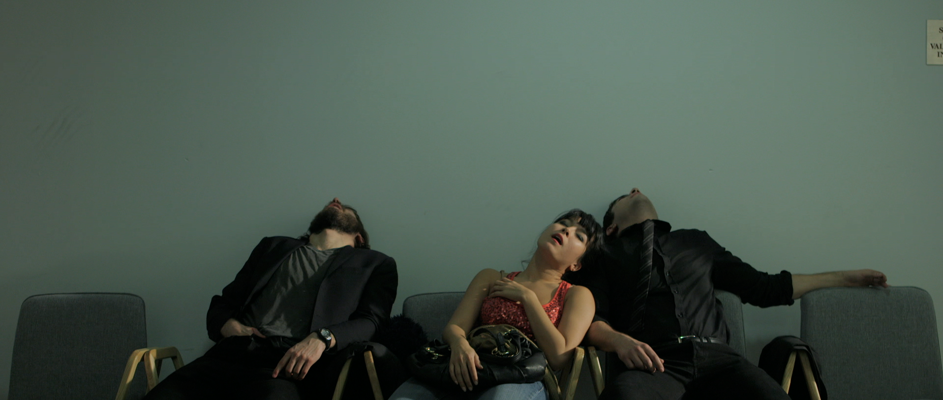
How Make a Feature Film with One Crew Member.
When I was young and silly, I made movies with only one or two friends, a light, a camera and a microphone. As I got older, the freedom (and terror) of that experience got lost. So with the devoted encouragement of two old friends, I wrote a script for us to shoot, and together we hurled ourselves into simply making something we loved. Lambs to the slaughter.
Our budget was only what we had saved up from working over the last few years. We all worked our full-time jobs during the production and shot nights and over the weekends. We had one light, and one crew member… myself. Evan, Mac and Margaret were practically super-human. They learned to lav themselves, do their own make-up, and sometimes even performed while holding their own key-light or boom.
We made a movie about friendship and trust, the bedrock of the production as much as the story. We weren’t aware of it at the time, but what Christian and Wyatt do for each other is what we were doing for one another. We protected each other, fought for each other, and held each other together when things fell apart. It was laughably hard. But it felt like filmmaking again

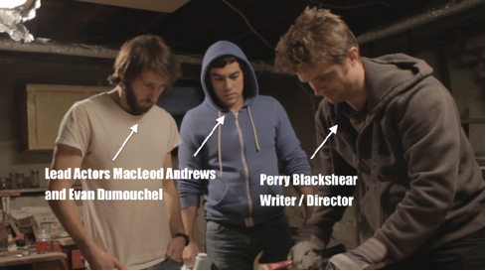
FULL CREDITS

Director/Director/Producer Perry Blackshear
Co-producers Kimberly Parker
Evan Dumouchel
MacLeod Andrews
Cinematographer Perry Blackshear
Editor/VFX Perry Blackshear
Associate Producer Elena Greenlee

CAST

Wyatt Macleod Andrews
Christian Evan Dumouchel
Mara Margaret Drake
Psychiatrist Mick Casale
Sandy Elena Green
Kat (voice) Julia Guo
Hannah Kimberly Parker
Hannah (voice) Jessie Kim
Hannah (photo) Lauren Parkinson
Girl at Work Amaani Hamid
Hipster Sketchball Ben Blackshear
Polish Guy Perry Blackshear
Man in Subway Eric Ohrt
Workplace Colleagues Sang Wook Kim
Perry Blackshear
Matt Lawrence
Laura Ambrose
Carlos Palacio
POST PRODUCTION

Sound Design / Foley Perry Blackshear
Additional Editor Evan Dumouchel
Assistant Editor Kelly Teacher
Photo Artist Laura Johnson
Sound Mixing / Mastering Jordan King

SPECIAL THANKS

Chloe Blackshear
Lindesay Harkness
Perry J Blackshear
Chaz Lee
Ben Blackshear
Debbie Blackshear
Joe Blackshear
Sam Blackshear
Leslie Blackshear
Emily Temple
Joey Kuhn
Pamela Romanowsky
Zelmira Gainza
Kiara Jones
Fern Diaz
Magdalene A Brandeis
Jonathan Brandeis
Josef Wladyka
Ani Simon-Kennedy
Cailin Yatsko
Márcia Nunes
Ron Eyal
Emily Kaplan
Anja Marquadt
Ryan Silbert
Elena Greenlee
Oliver Hill
Eliza Bagg
Gabrielle Demeestere
Ana Vallejo
Toren Hardee
Laura Turner
Nick Turner
Mick Casale
Amy Fox
Jon Tintori
Miranda Sherman
Carol Dysinger
Tony Janelli
Peter Stein
Gail Segal
Sandi Sissel
Laura Johnson
Belle Fabel
Bruce Dumouchel
Laura Dumouchel
Renee Dumouchel
Alexandra Duchesne
JF Duchesne
Damir Vukovljak
Brent Butler
Alison Maggart
Robbie Burton
Cob Burton
Megan Verbeck
Jenna Schoenefeld
Daniel Di Tomasso
Keidy Moreno
Sarah H. Haught
Adam Stovall
Daniel DiTomasso
Alex Slavin
Jeff King
Mem Kennedy
Tony Hamilton-Shannon
Anthony Rey Perez
Matilda Andrews
Jack Andrews
Jackson Andrews
Liz Gatewood Andrews
Stu Pollard
Chris Parson
Jeffrey Paul King
Erin Beasley
Kiley Donovan
Steven Canals
Beto Skubs
Tony Hamilton-Shannon
Chris Hill
Shruti Swaminathan

